Traceback (most recent call last):
File "step2.1_SIFT_descriptor.py", line 16, in <module>
sift = cv2.xfeatures2d.SIFT_create()
AttributeError: 'module' object has no attribute 'xfeatures2d'
sun@ubuntu:~/sun/tensorflow_sun/CIKM-Cup-2017-master/code/step2_Local_Descriptor_Trace_Tracking$ python step2.1_SIFT_descriptor.py

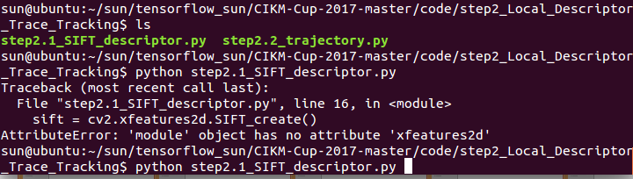

$ sudo pip uninstall opencv-python
$ sudo pip uninstall opencv-contrib-python
$ pip install --user opencv-contrib-python==3.3.0.10
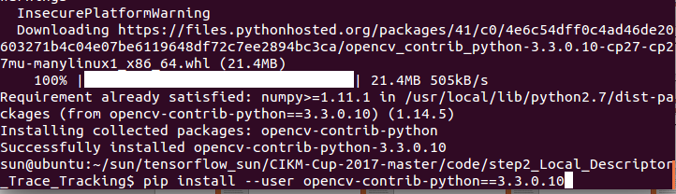

OK，问题解决！
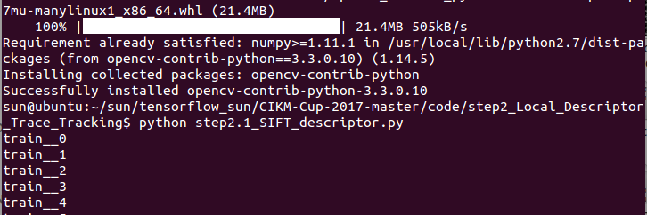

测试：

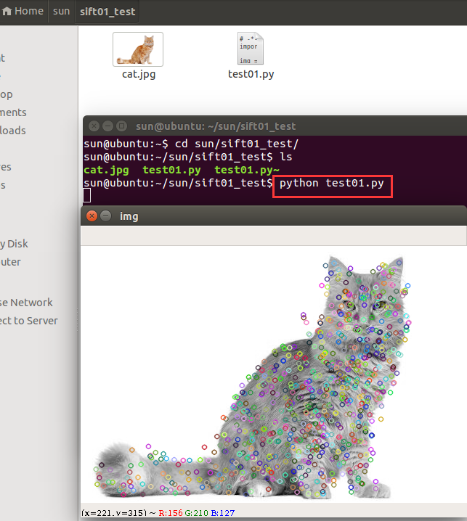

参考：
https://www.cnblogs.com/Allen-rg/p/9667926.html
